FRAUD DETECTION USING MACHINE LEARNING
Credit Card Fraud Detection System
1. Project Overview
The Credit Card Fraud Detection System is a machine learning-based application designed to identify fraudulent and suspicious credit card transactions.
The project uses an imbalanced transaction dataset and implements supervised and unsupervised machine learning algorithms to detect known fraudulent transactions as well as potentially unusual transaction patterns.
Random Forest and XGBoost are used for fraud classification, while Isolation Forest is implemented for anomaly detection. A Streamlit application provides an interactive interface for analyzing individual transactions.
2. Problem Statement
Financial platforms face challenges in identifying fraudulent transactions because fraudulent activities represent only a small proportion of total transactions.
Traditional detection approaches may fail to identify suspicious transactions, particularly when fraud patterns change or new patterns emerge.
The objective of this project is to develop a machine learning-based fraud detection system that identifies fraudulent transactions, minimizes false predictions and detects potentially unseen suspicious patterns.
3. Project Objectives
- Obtain and analyze an imbalanced credit card transaction dataset.
- Perform exploratory data analysis (EDA).
- Develop at least two machine learning fraud detection models.
- Handle class imbalance without data leakage.
- Compare models using Precision, Recall, F1-score and PR-AUC.
- Analyze false positives and false negatives.
- Evaluate models on unseen test transactions.
- Identify potentially new suspicious transaction patterns using anomaly detection.
4. Dataset Description
Dataset: Credit Card Fraud Detection Dataset – Kaggle (ULB)
Description | Count
Total transactions | 284,807
Normal transactions | 284,315
Fraudulent transactions | 492
Input features | 30
Target column | Class
The dataset contains anonymized transaction features (V1–V28), transaction time (Time) and transaction amount (Amount).
The target variable Class indicates whether a transaction is normal (0) or fraudulent (1).
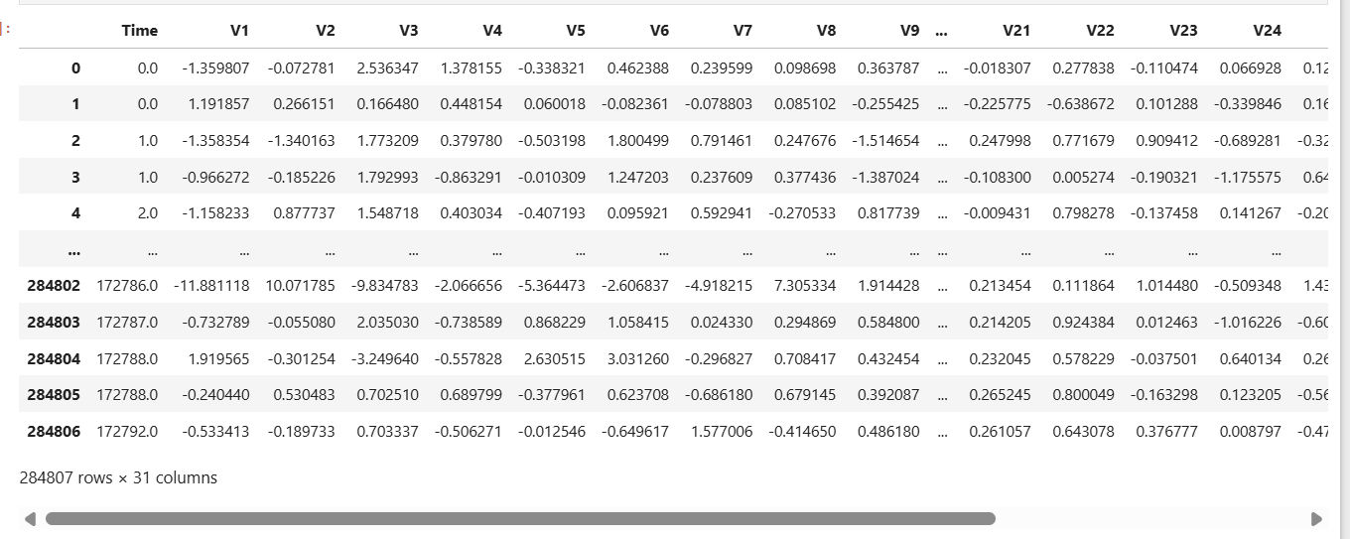
Figure 1: Credit card fraud dataset showing sample transaction records, dataset dimensions and features.
5. Project Implementation Procedure
Step 1: Data Collection and Exploratory Data Analysis
The dataset was loaded using Pandas. EDA was performed to understand the dataset structure, feature distributions, missing values, duplicate records and class imbalance. Visualizations were used to examine transaction patterns.
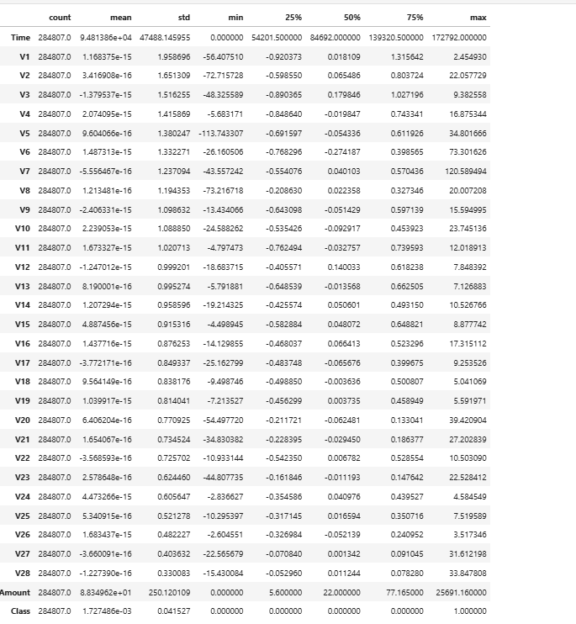
Figure 2: Dataset information, descriptive statistics and exploratory data analysis.
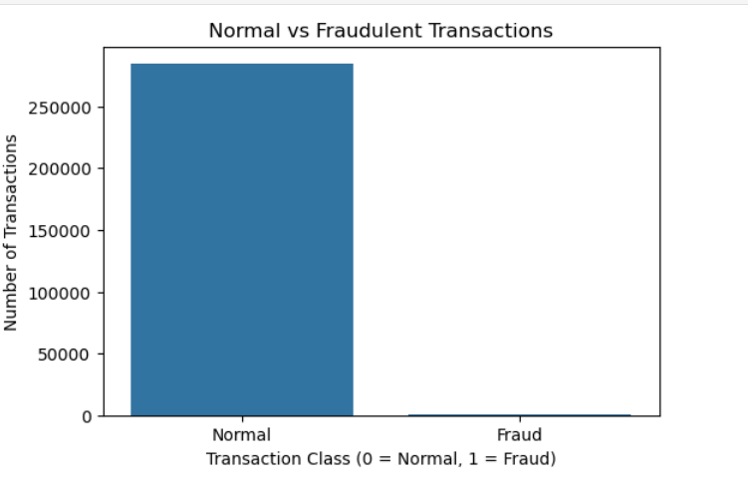
Figure 3: Distribution of normal and fraudulent transactions illustrating class imbalance.
Step 2: Data Preprocessing
- Checked and removed duplicate records.
- Separated input features and target variable.
- Divided data into training, validation and testing sets using stratified sampling.
- Applied RobustScaler to Time and Amount for supervised models.
- Applied StandardScaler to the Isolation Forest features.
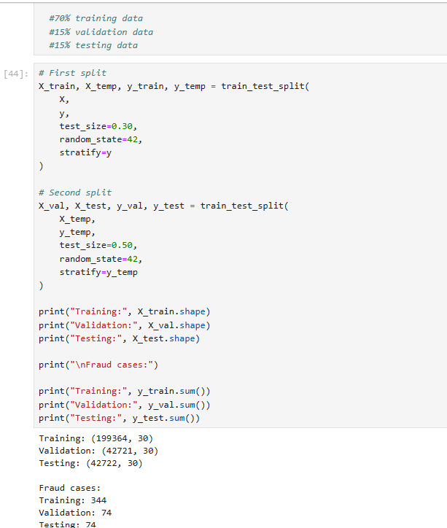
Figure 4: Data cleaning, feature preparation and stratified training, validation and testing split.
Step 3: Handling Class Imbalance
The dataset contains a very small number of fraudulent transactions compared with normal transactions.
SMOTE was applied only to the supervised training data to generate synthetic minority-class samples. Validation and testing data were kept unchanged to prevent data leakage and preserve realistic evaluation conditions.
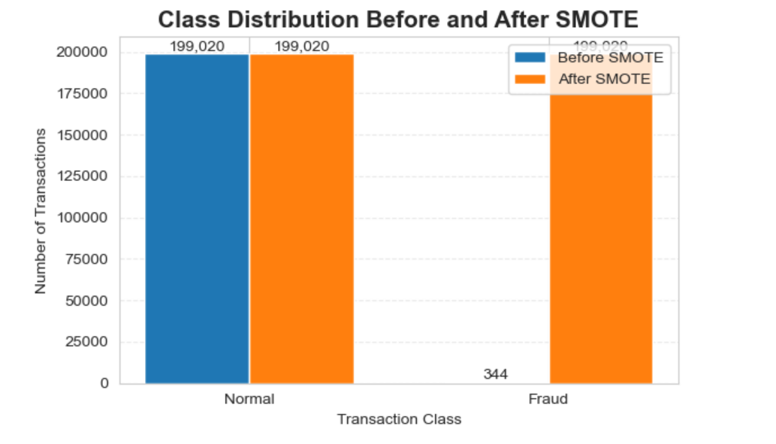
Figure 5: Class distribution before and after applying SMOTE to the training data.
Step 4: Machine Learning Model Development
Three algorithms were implemented:
- Random Forest: An ensemble classification algorithm that combines multiple decision trees to identify fraudulent transactions.
- XGBoost: A gradient boosting algorithm that sequentially builds decision trees to improve classification performance.
- Isolation Forest: An unsupervised anomaly detection algorithm trained on normal transactions to identify unusual transaction patterns.
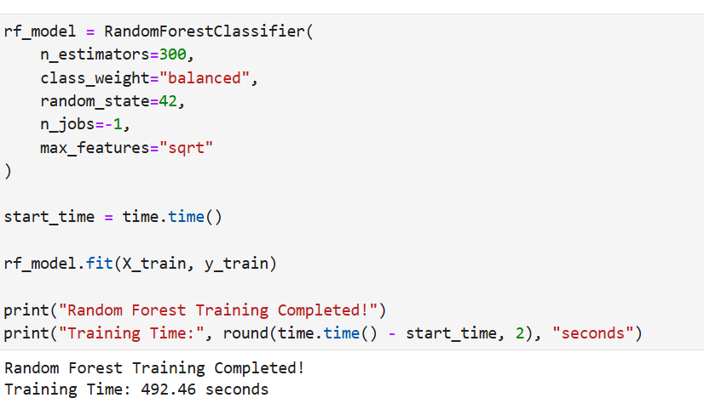
Figure 6: Random Forest model configuration and training execution.
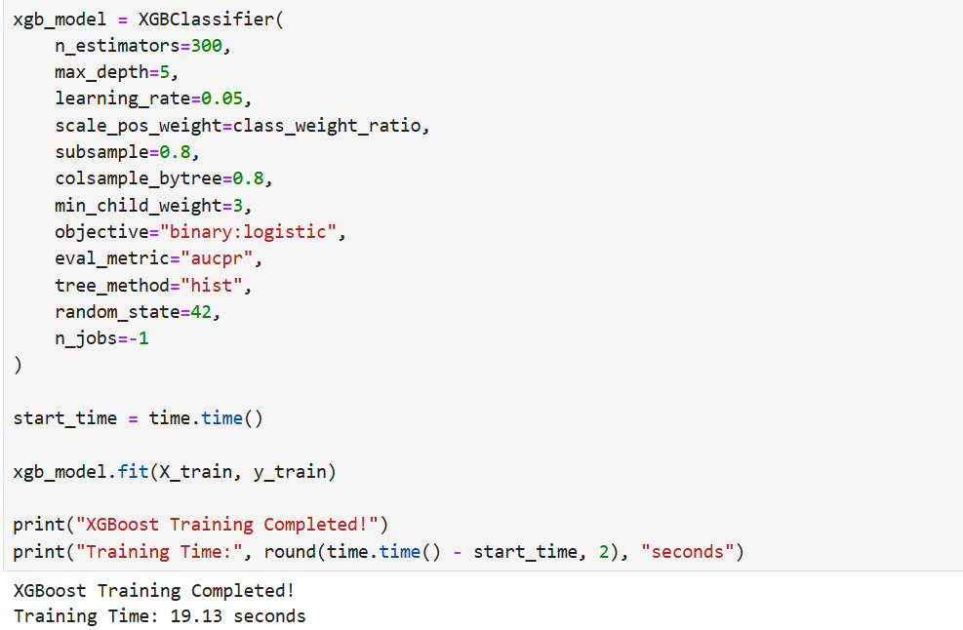
Figure 7: XGBoost model configuration and training execution.
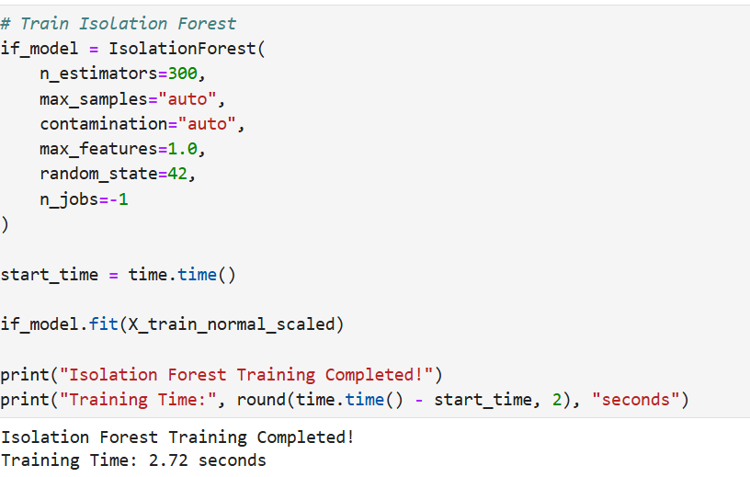
Figure 8: Isolation Forest training using normal training transactions.
Step 5: Model Evaluation and Comparison
Random Forest and XGBoost were compared using:
- Precision
- Recall
- F1-score
- PR-AUC
Confusion matrices and classification reports were also used to understand model performance.
Isolation Forest was evaluated separately as an anomaly detection model using labelled validation and test transactions.
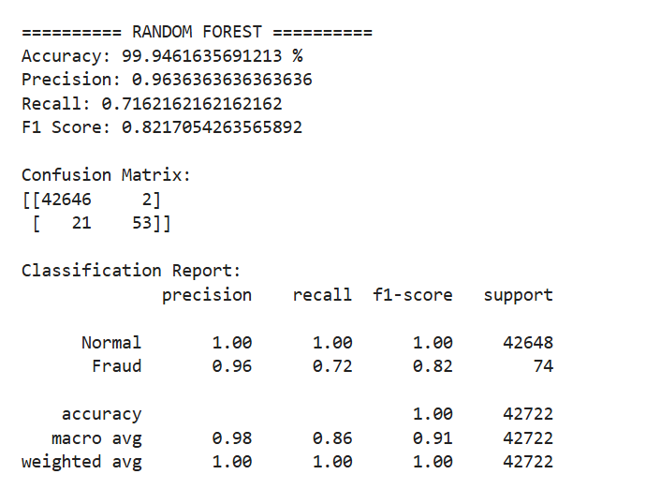
Figure 9: Random Forest classification report and confusion matrix.
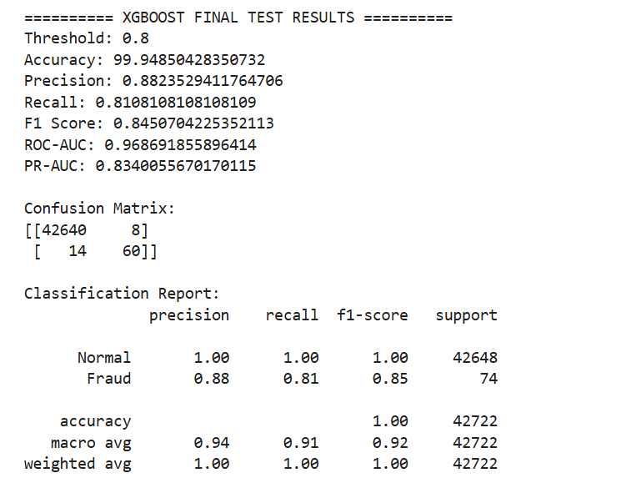
Figure 10: XGBoost classification report and confusion matrix.
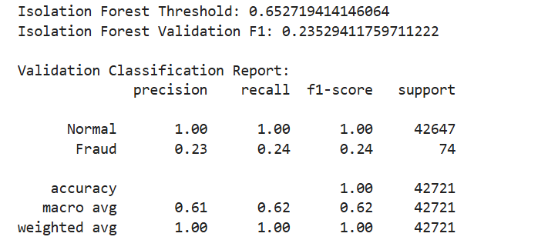
Figure 11: Comparison of model performance using Precision, Recall, F1-score and PR-AUC.
Step 6: False Positive and False Negative Analysis
- False Positive (FP): A legitimate transaction incorrectly classified as fraudulent. This may cause unnecessary transaction declines or customer inconvenience.
- False Negative (FN): A fraudulent transaction incorrectly classified as normal. This may result in financial losses.
The project considers both error types because reducing missed fraud while avoiding unnecessary declines is important in financial systems.
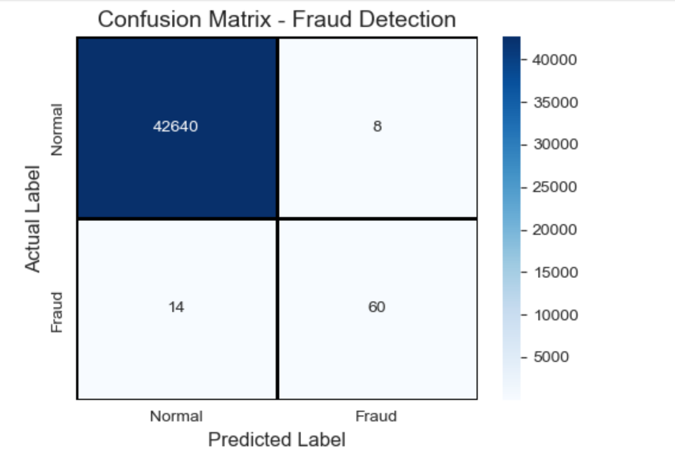
Figure 12: False positives and false negatives identified through confusion matrix analysis.
Step 7: Unseen Transaction Testing and Unknown Pattern Detection
The trained models were tested on transactions that were not used during training.
Random Forest and XGBoost identify fraud based on patterns learned from labelled training data. They may struggle with completely new fraud patterns.
To address this limitation, Isolation Forest was implemented to identify transactions that differ from normal transaction patterns learned during training.
This provides an additional anomaly detection mechanism for potentially unseen suspicious transactions. However, an anomaly is not necessarily fraud and requires further investigation.
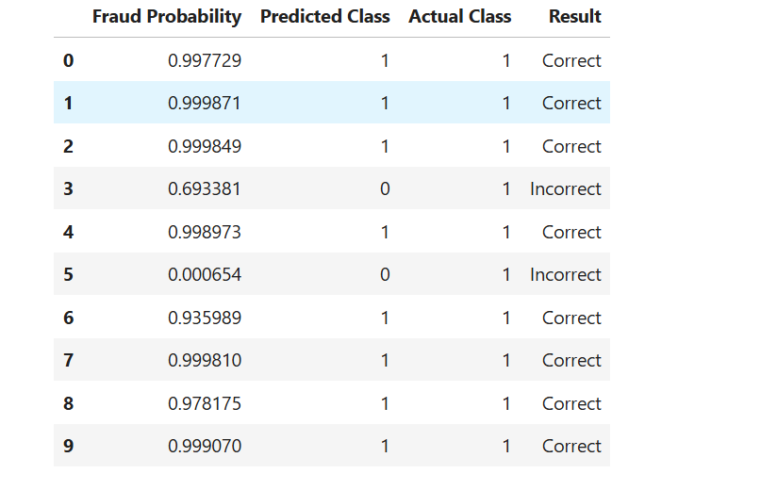
Figure 13: Prediction results for an unseen fraudulent transaction.
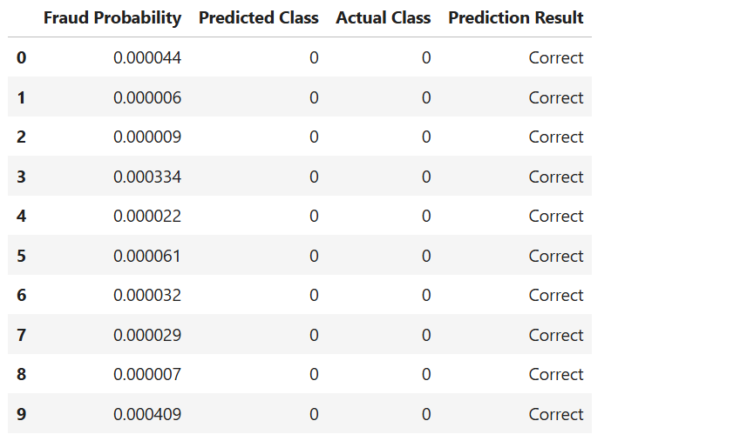
Figure 14: Prediction results for an unseen legitimate transaction.
Step 8: Model Saving and Application Development
The trained models, scalers and feature information were saved using Joblib.
A Streamlit application was developed to accept individual transaction details and display:
- Random Forest fraud prediction.
- XGBoost fraud probability and prediction.
- Isolation Forest anomaly detection result.
- Comparison of model predictions.
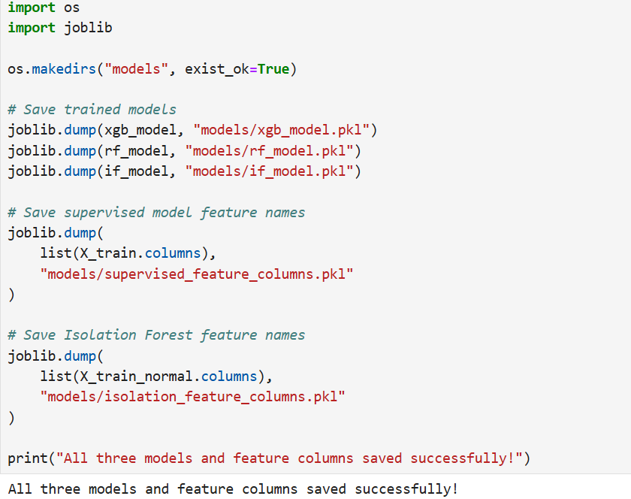
Figure 15: Trained machine learning models, scalers and feature information saved in the project directory.

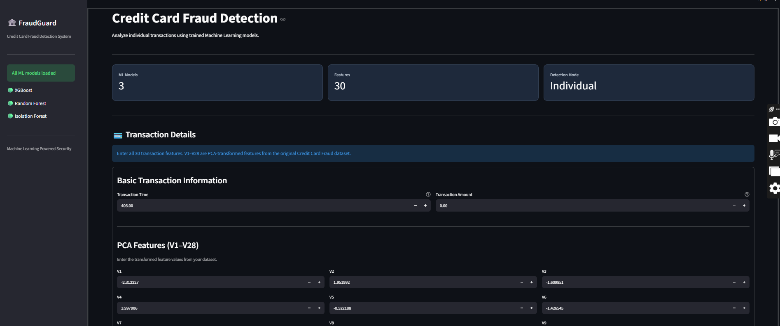
Figure 16: Credit Card Fraud Detection application dashboard.
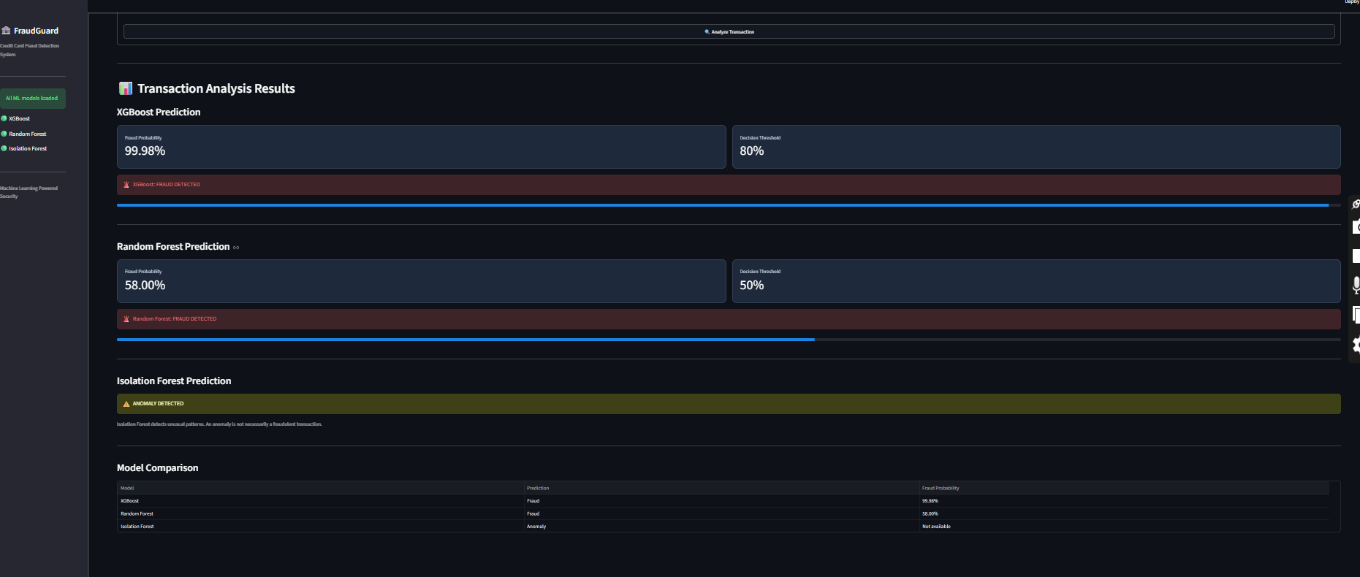
Figure 17: Streamlit application detecting a potentially fraudulent transaction.
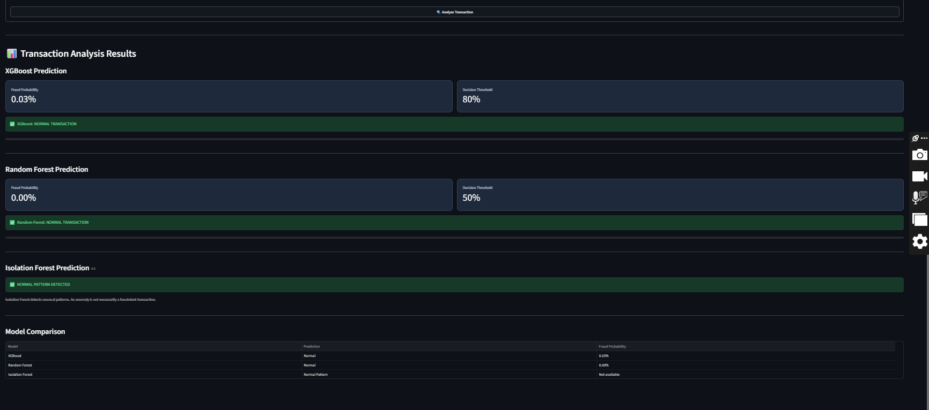
Figure 18: Streamlit application analyzing a normal transaction.
Technologies Used
Category | Tools
Programming | Python
Data Analysis | Pandas, NumPy
Visualization | Matplotlib, Seaborn
Machine Learning | Scikit-learn
Boosting | XGBoost
Imbalance Handling | SMOTE
Model Saving | Joblib
Web Application | Streamlit
Development | Jupyter Notebook, VS Code
System Workflow
Dataset Collection → Exploratory Data Analysis → Data Preprocessing → Stratified Data Splitting → SMOTE on Training Data → Model Training → Model Evaluation → Threshold Optimization → Unseen Transaction Testing → Anomaly Detection → Streamlit Application.
Results and Model Comparison
The project compares Random Forest and XGBoost using Precision, Recall, F1-score and PR-AUC.
Isolation Forest provides a separate anomaly detection approach to identify unusual transactions.
Final performance values should be reported using the actual held-out test results. The model comparison should consider fraud detection performance and the impact of false positives and false negatives, rather than accuracy alone.
Limitations
- New fraud patterns may not be detected by supervised models if they differ significantly from training patterns.
- Isolation Forest may flag legitimate but unusual transactions as anomalies.
- The dataset contains anonymized features, limiting direct interpretation.
- The current Streamlit application supports individual transaction analysis.
Future Enhancements
- Add bulk transaction detection using CSV uploads.
- Integrate real-time transaction monitoring.
- Store transaction predictions and history in a database.
- Implement continuous model monitoring and retraining.
- Explore advanced anomaly detection methods for evolving fraud patterns.
Conclusion
The project demonstrates an end-to-end machine learning approach to credit card fraud detection using an imbalanced transaction dataset.
Random Forest and XGBoost are used to classify fraudulent transactions, while Isolation Forest provides an additional approach for detecting unusual and potentially unseen suspicious patterns.
The project addresses class imbalance, model evaluation, false positive and false negative analysis, and unseen transaction testing. The Streamlit application makes the developed models accessible through an interactive fraud detection interface.

